**Adventures in Museo Capellini: A Virtual Experience**

Name of the Group: Rumi

Name of the Participants:

1. Atousa Heidarnia

2. Evan Arnoldi Sebayang

3. Mohammad Javad Farokhi Darani

1. The Context

(a) The museum and its content/collections:

The Capellini Museum in Bologna is a renowned institution dedicated to paleontology. Its collection includes a vast array of fossilized remains, with a special emphasis on fossil teeth. These artifacts provide valuable insights into ancient ecosystems and evolutionary patterns.

(b) The location and its map/plan:

The Capellini Museum is situated in the heart of Bologna, Italy, near the city center. It is easily accessible to visitors, and a detailed map will be provided to guide their visit.

(c) Institutional Goal:

The institutional goal of the Capellini Museum is to promote public engagement and understanding of paleontology and its relevance to our understanding of Earth's history. The museum aims to foster a sense of wonder and appreciation for the natural world through interactive experiences.

(d) Cognitive Goals:

1. Increase Knowledge: To enhance visitors knowledge and understanding of paleontology, specifically focusing on the significance of fossil teeth in reconstructing ancient ecosystems and evolutionary patterns.

2. Foster Critical Thinking: To encourage visitors to think critically and analytically about the relationship between geology, paleontology, and the natural world, particularly in terms of the connections between humans and the environment.

3. Promote Scientific Inquiry: To stimulate visitors curiosity and encourage them to ask questions, explore evidence, and engage in scientific inquiry related to fossil teeth and their relevance to our understanding of Earth's history.

4. Develop Appreciation: To cultivate an appreciation for the beauty, complexity, and diversity of ancient life forms, as revealed through the study of fossil teeth.

(e) Star Assets (must-see of the museum):

1. Fossil of Diplodicus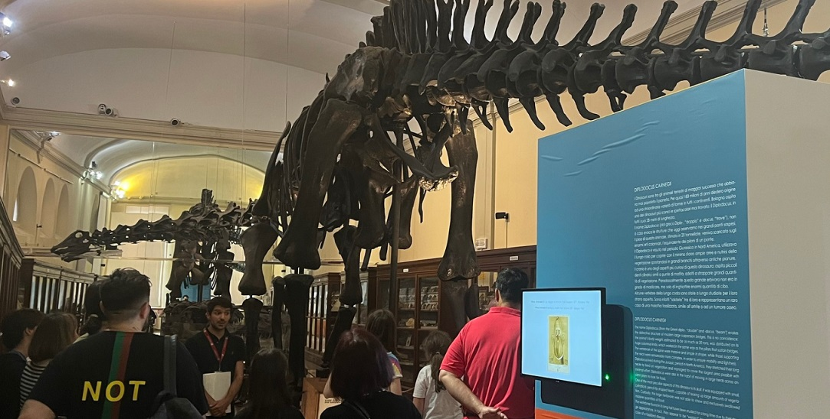

2. Fossil of Scelidoterium 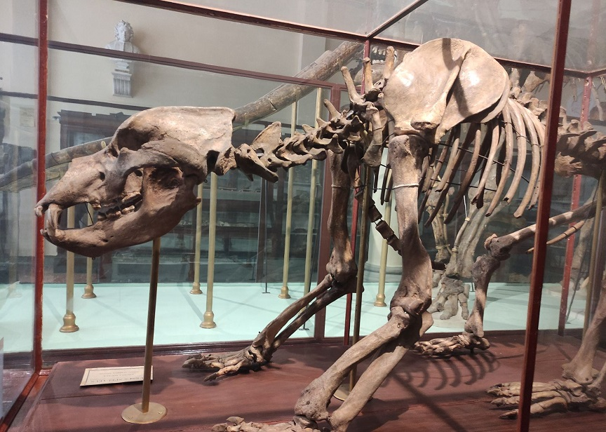

3. Ancient hominid tooth collection

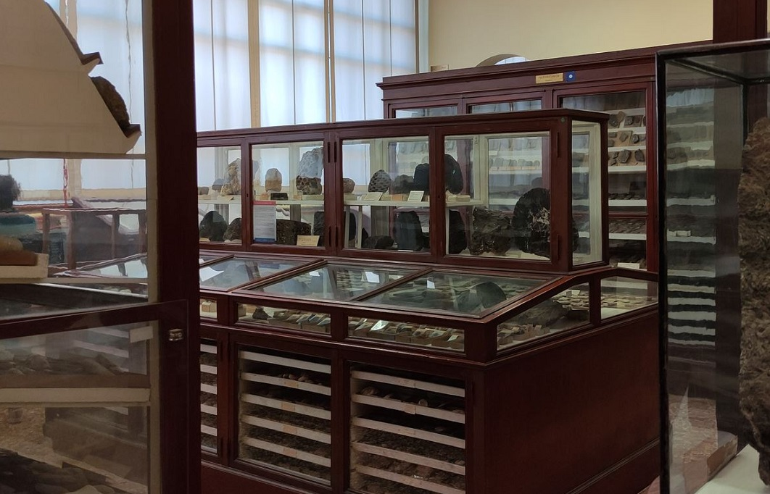

1. Fossil of Diplodicus: The Diplodocus fossil represents a genus of long-necked, plant-eating dinosaurs that lived during the Late Jurassic period. It is known for its massive size, with a long neck and tail, and is one of the most recognizable dinosaurs.
2. Fossil of Scelidoterium: The Scelidotherium fossil represents an extinct genus of ground sloths that lived during the Pleistocene epoch. These large mammals had powerful limbs and curved claws, adapted for digging and climbing.
3. Ancient hominid tooth collection: This collection focuses on the teeth of ancient hominids, such as early human ancestors. It presents a unique opportunity to explore the dental remains of our evolutionary relatives, shedding light on human evolution, behavior, and adaptation over time.

(f) Target Audience:

Target Audience: Visitors of all age – With increased focus to Children and Young Adults. (1, 4, 5)

2. The Audience

(a) Motivations:

Visitors of Children and Young Adults are motivated by curiosity, hands-on experiences, and the opportunity to learn new things. Especially for children, they enjoy interactive and engaging activities that make learning fun and memorable.

(b) Barriers:

1. Limited Attention Span: Visitors in this age group may have limited attention spans, and it is crucial to design engaging and interactive experiences that capture and maintain their interest.

2. Age-appropriate Language and Content: The language and content should be tailored to the age group to ensure comprehension and engagement.

(c) Capabilities:

Today’s visitors are familiar with digital technologies and comfortable using smartphones, tablets, and interactive touchscreens. They enjoy interactive experiences, multimedia content, and gamified activities.

(d) Devices:

Visitors will be presented with the usage of a virtual reality headset. The headset will allow the visitors to see 3D Models of select exhibits on a true scale of size.

3. Concept

(a) Problem(s):

The project aims to overcome the limited attention span of children and young adult visitors and provide an engaging and educational experience centered around virtual reality of the museum’s exhibits, capturing their interest in paleontology.

(b) Project Solution:

Our project will create an interactive and immersive digital experience that focuses on the fascinating world of fossils. Through gamified activities, interactive storytelling, and age-appropriate content, we aim to captivate visitors's attention and foster their curiosity and understanding of paleontology concepts.

(c) Museological Approach:

The museological approach will combine scientific accuracy, hands-on learning, and storytelling to create an immersive

4.Requirements:

(a) Must:

- User-friendly and intuitive interface when using the virtual reality devices, with simple navigation and clear instructions.

- Interactive and engaging activities, including games, puzzles, and quizzes, to capture visitors's interest and promote active learning.

- Compatibility with common devices such as tablets or smartphones, ensuring smooth performance and responsiveness.

- Accessibility features to accommodate visitors with disabilities, such as adjustable font sizes, audio descriptions, and color contrast options.

(b) Should:

- Incorporate gamification elements, such as points, badges, and levels, to enhance the learning experience and motivate visitors to progress.

- Provide educational content related to fossils, teeth, and paleontology, presented in a fun and informative way with age-appropriate language.

- Include a progress tracking system to monitor visitors's achievements and provide feedback on their learning progress.

- Support multiple languages to cater to international visitors and enhance accessibility.

(c) Could:

- Offer interactive quizzes or challenges to test visitors's knowledge and reinforce key concepts.

- Include augmented reality features to bring fossils to life, allowing visitors to virtually interact with 3D models and see them in their surroundings.

- Integrate social sharing functionalities, allowing visitors to share their experiences, achievements, and favorite findings with friends and family.

(d) Won't:

- Require complex technical setups or expensive hardware, ensuring accessibility and ease of use for visitors.

- Include excessive text or use difficult scientific terminology, opting for visual aids and simplified explanations to enhance understanding.

5. Ideation:

(a) Experience (from the users' perspective):

- Visitors will embark on a virtual journey through the fascinating world of fossils and teeth, discovering the wonders of paleontology.

- They will actively participate by using the augmented reality devices, fostering hands-on learning and critical thinking.

- Through engaging activities, they will learn about different types of fossils, their formation processes, and the significance of teeth in paleontology.

(b) Conceptual map:

- The interactive application will feature distinct sections dedicated to different types of fossils (e.g., dinosaurs, marine creatures) and types of teeth (e.g., carnivores, herbivores).

- Each section will offer a variety of interactive activities, educational content, and multimedia resources, such as images, videos, and 3D models.

- Visitors can freely navigate between sections and explore their favorite topics.

(d) The story:

- The interactive narrative using Twine simulate how visitors go through the upgraded museum with VR devices ready for usage.

- They will be able to compare how the exhibits comes to life with the added virtual reality devices that will enhance their experience while exploring the museum.

(f) Interaction between the application and users:

- Interaction Diagram: Visitors will be presented virtual reality headset in the entrance that is to be returned after they finished their visit to the museum. The headsets can be used in exhibits to see a real-time graphic rendition of the fossils during their lifetime, such as the 3D model of a Diplodicus, on a true scale.

(g) Foreseen workflow:

- Visitors will be presented a choice to pick up the virtual reality headset or not during their visit.

- They choose which exhibit they wanted to see during their visit.

- After arriving to the exhibit, the visitor can first see the exhibit as it is without wearing the virtual reality headset.

- Then, they are able to wear it to compare the fossil with the 3D rendition model of the still-living fossils they are seeing.

(h) Set-up:

- Hardware: Virtual reality headsets plus powerful workstations that are capable of emulating the virtual reality landscape when worn.

- Software: Development tools and frameworks suitable for creating virtual reality landscape.

- Media: Digital assets, including high-quality images, videos, and 3D models of fossils and teeth, to enhance the visiting experience.

(i) Further development and maintenance issues:

- Consider future updates to add new content, activities, or features based on user feedback and emerging educational trends.

* Regular maintenance to ensure compatibility with new devices, operating system updates, and security patches, providing a seamless experience for users.

6. Disruption:

* Identify potential challenges, such as technical limitations or time constraints, that may arise during the development and implementation phases, such as limitation of space and feasibility of wearing virtual reality headsets.
* The amount can be challenging if there is an influx of visitors wanting to try the virtual headsets.
* Outline strategies to overcome these challenges, such as conducting thorough testing, allocating sufficient resources, and seeking technical support if needed.
* Alternatively, the virtual reality headsets can be reserved to one per exhibit instead of multiple headsets being presented in the entrance.

7. Team roles and work:

1. Atousa Heidarnia: Working on the Design Brief as the main focus.

2. Evan Arnoldi Sebayang: Working on the Twine Scenario while also revising the Design Brief.

3. Mohammad Javad Farokhi Darani: Working on the PACT Toolkit + Deck and Presentation Slides with Figma.

8. Twine Scenario: https://evanarnoldi.github.io/rumi_museology_project/